Introduction
Most significantly, the growth of technology and the emergence of new interaction technologies have enabled an expansion regarding the input and output methods available in human-computer interaction. This means that in the modern world input is no longer bounded to window-based interfaces, keyboards or mice. Rather, the interaction between man and the computer relies on tangible communication, ambient displays, sensing in public spaces and mobile and ubiquitous devices (Antona & Stephanidis, 2017). Under these circumstances, it is imperative to recognize that the user experience design influences the mode of relationship between the user and the product. Because of this, this report focuses on developing an interactive game that enables the user to form a variety of network connections between different computers without a central control system (Bollini, 2017). This discussion introduces the prototype of the interactive platform that allows the user to observe connections between computers through a tangible user interface.

Design and Concept
The main concept of the game is to represent and develop various network connections by using a tangible user interface that allows the user to project the networks on a computer or television screen. The game allows the user to manually place objects on the input board and project the interaction between these boards on the computer. Using this mode of interaction, the user can illustrate different computer connections. For instance, the diagram below shows the flow of information from the input phase to the display of connections on the computer screen
Change of objects and placement locations to develop network connections
Display of Objects as different modes of units forming network connections
Placement of Objects at different locations on the input board

Diagram 1: Flow of game data
As observed, the key user can develop a range of network connections based on the information provided by the TUI. This game provides an interactive manner of developing network connections between computers. It also creates opportunities for developing further connections that have not yet been established today (Bollini, 2017). The input board is quite innovative, it attracts the user and encourages the user to have a smooth experience while developing and displaying connections. As such, the game is an opportunity for teaching network connections as well as inducing further learning and analysis in the scope of network connections. Nonetheless, it is important to integrate a guide that provides users with instructions at the beginning of the game. This ought to improve the user experience by enabling users to understand how the game works before they can play. Additionally, the game should also integrate a visible alert option that instructs the user on the type of connections made and whether the type of network connection registered by a user in achievable practically. Although the objects are accurately displayed on the screen, it is vital to develop unique objects that almost replicate computers, routers, and switches in real life. This will enable a more realistic approach when the user inputs data.
Prototype
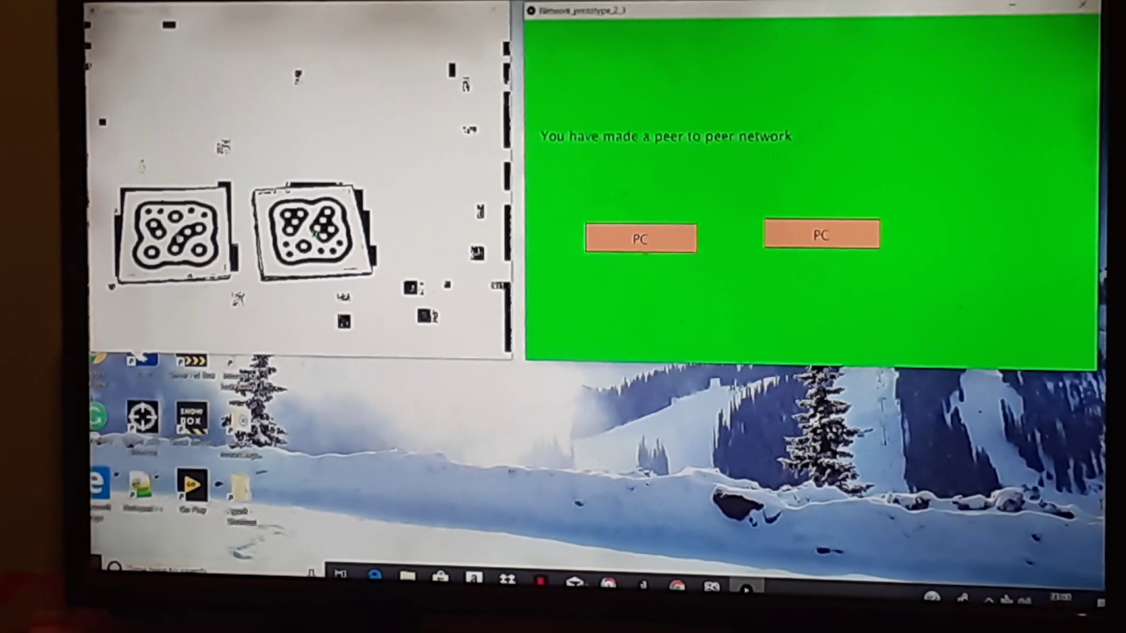

Figure 1: Peer to Peer Network
The diagram above is a screenshot of the formation of a peer-to-peer connection made in the game. The left side of the screen displays the interactive board that projects the physical movements of data inserted into the game by the user. When the user places both objects on the input board, they are reflected on the right side of the screen as sample network connections. This prototype enables the user to use different objects to display different connections. In the process of turning the concept into a running prototype, the input board was quite useful. It was imperative to install the network prototype framework to get a clear display of the context of data reflected on the input board.

Tangible Interaction
The TUI can exhibit connections formed between computers, switches, and routers. Based on the prototype, the user can form these connections by placing different objects at the input board. Similar objects are used to represent a singular entity. For instance, the image above shows the connection formed between two computers. This way, the game allows the user to form graphical representations of connections between computers and other network devices using physical objects. The image below shows a three-tier network developed between three objects on the input board. As observed, placing these objects in a certain direction enables the computer to identify the type of network and displays the data in a textual manner. 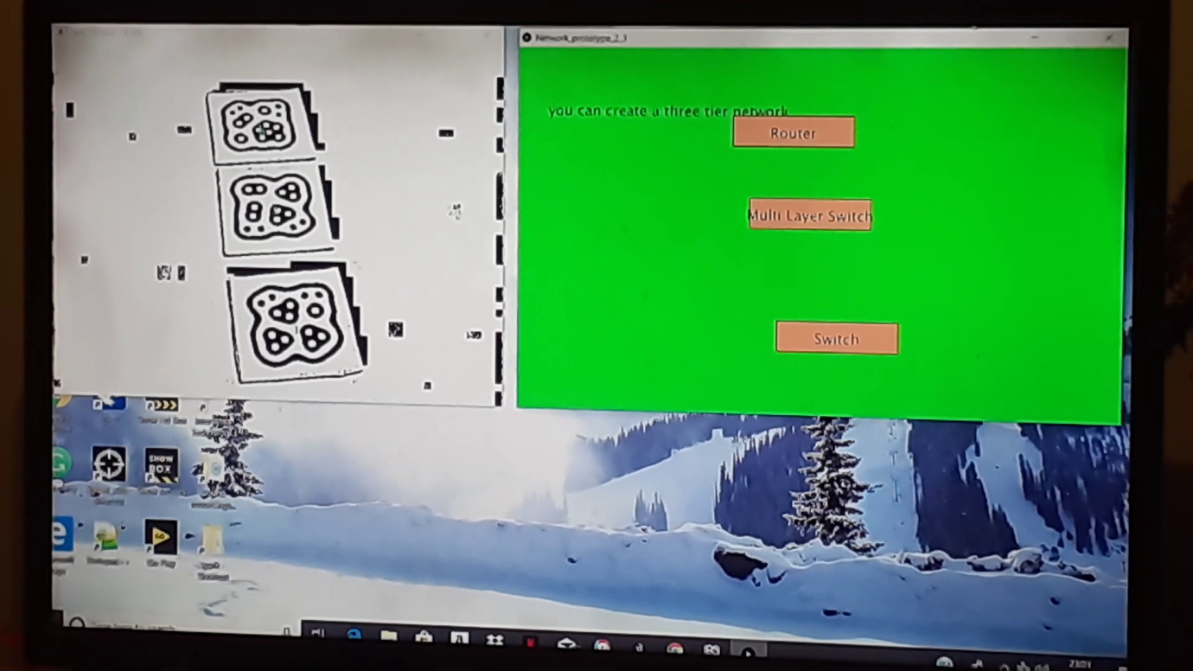
Figure 2: Three Tier Network
The difference between the physical objects is manipulated to signify different network entities on the display screen. This enables the prototype to display network connections based on the actual structure of each object.

Evaluation
To test the game, a video was recorded while different objects are placed on the input board. Through the video, it becomes imperative that the design of the game is based on the difference between the objects (Roth, 2017). Additionally, the outcome of the game is based on the specific placement of the physical object. In this manner, how the user places the physical objects determines how the game will reflect the direction and type of network connection.

References
Antona, M., & Stephanidis C. (2017). Universal Access in Human-Computer Interaction: Designing Novel Interactions. Proceedings of the 11th International Conference on Universal Access in Human-Computer Interaction (Part II). London: Springer.
Bollini, L. (2017). Beautiful interfaces. From user experience to user interface design. An International Journal for All Aspects of Design, 89-101.
Roth, R. E. (2017). User Interface and User Experience (UI/UX) design. Geographic Information Science & Technology Body of Knowledge, 38.

